|  |  |  |  |
| --- | --- | --- | --- |
|  | Functional Requirement Specification | |  |
|  | | |
| Credit Workflow | | |
|  | | |
| **Author:** | Maggie Cheng | |
| **Creation date:** | Thursday, 11 November, 2021 | |
| **Last update:** | Wednesday, 29 June, 2022 | |
| **Revision Number:** | v0.4 | |

Table of Contents

1 Document References 3

2 Document Revisions 3

3 Background 5

4 Objective 5

5 Purpose of This Document 5

6 Scope 5

6.1.1 In Scope 5

6.1.2 Out of Scope 6

7 Current Methods and Procedures 7

7.1 General Functions 7

7.2 Mass Upload 8

7.3 Audit Trail 8

7.4 Approval Flow 9

8 Summary of Improvements 11

8.1 Functional Improvements 11

8.1.1 Open Credit Customer Profile 12

8.1.2 Update Credit Customer Profile 13

8.1.3 Update VBA 14

8.1.4 Close Credit Customer Profile 15

8.1.5 Reopen Credit Customer Profile 16

9 Assumptions and Constraints 17

9.1.1 Assumption 17

9.1.2 Constraints 17

10 Functional Area System Functions 18

10.1.1 Generic function 18

10.1.2 Open a new credit customer 24

10.1.3 Update an existing credit customer 26

10.1.4 Update VBA 27

10.1.5 Close an existing credit customer 28

10.1.6 Reopen a closed credit customer 29

10.1.7 Update partner function linkage in SAP 31

10.2 Approval Flow 32

10.3 Screen Navigation 33

10.3.1 Payer Information 33

10.3.2 AR Information 34

10.3.3 BR Information 35

10.4 Integration Interface 35

10.5 Data Migration 36

10.6 Access Right Definition 36

Appendix A: Credit Policy – Appendix C 39

Appendix B: Credit Policy – Appendix E 39

Appendix C: Credit Workflow Fields Description 39

Appendix D: RTRMD130-Business Partner Credit Limit Master Record Maintenance Blueprint 39

References & Revisions

# Document References

|  |  |  |  |
| --- | --- | --- | --- |
| Document Name | Version | Author | File Directory |
|  |  |  |  |
|  |  |  |  |
|  |  |  |  |
|  |  |  |  |

# Document Revisions

|  |  |  |
| --- | --- | --- |
| Version | Date | Revision Description |
| 1.0 | 22 Mar 2022 | Initial Draft |
|  |  |  |
|  |  |  |
|  |  |  |

Executive Summary

SCCHK Sales and Marketing Department and Finance Department require a communication and approval for the credit customer detail terms and settings. And Credit Workflow is part of the daily operation. Due to the SAP project, Credit Workflow requires modification for fitting new process flow with SAP. After approval in the Credit Workflow, data will be updated to SAP for the Business Partner and the credit profile.

General Information

# Background

Due to the digitization strategy of the company, there will be an ERP system revamp within the company to migrate the legacy system to SAP S4 HANA. In light of the ERP system revamp, all the peripheral systems have to change and integrate with SAP S4 HANA.

# Objective

This project aims

1. For users to maintain credit customer and FSV reimbursement customer business partner
2. For users to open, approve, update, close and reopen credit profiles, and the approval result will update to SAP for record purpose
3. For users to update the partner function between the outlet and credit profile when the application state is open or reopen.

# Purpose of This Document

This document aims to describe the functional specification for system enhancement within Swire Coca-Cola Hong Kong. The content will be the foundation for later technical design. All examples and screenshots are for illustration and may differ to final system layout.

The detailed requirements on the infrastructure and/or functionality to be implemented by third party will not be described in this document.

The purpose of the document is to describe the functional requirements that need to support new / changed business or system process derived from SAP S4 Hana implementation.

# Scope

### In Scope

The project scope includes the following:

1. Integrate with SAP S4 HANA to sync the approved customer information for CRWF to retrieve
2. Support on screen input function for credit workflow application
3. Credit Workflow sync the approved payer BP and credit profile information back to SAP S4 HANA
4. Integrate with SAP S4 HANA to sync master data and the code and value to CRWF for pick list selection

Target user group includes:

- AWH (SA/SDR, AM, SM, BUM, Group Manager – Business Units & Cold Drink

- GT (SOE, AM, EXE, ASOM, GT Manager)

- Key Account (Executive/Account Manager, Channel Sales manager, Department Head)

- Finance (Finance team, Accountant, Finance Manager, Finance Director)

- Sales and Marketing Director

- General Manager

### Out of Scope

The following are considered out of project scope:

1. Mass upload workflow application
2. Maintain outlet business partner

Current System / Process Summary

# Current Methods and Procedures



## General Functions

1. Integrate an approved application from Credit Workflow Platform (CRWF) (based on K2 technology) to backend RBS/SDS system
2. Credit account creation
   1. Credit reopen application is agreed being not applicable in credit workflow. In case a reopen bill-to number is required, applicant should put in the “remark” for reusing previous bill-to number in submitting new application, Finance will adjust and confirm the use of new bill-to number or existing bill-to number.
   2. System will be able to alert user if the bill-to number has reopened for reuse and classify as reopen when integrating to RBS/SDS.
3. Credit account update
4. Credit account closure
   1. In case a bill-to number is linked with outlet, removal of bill to and outlet relationship via outlet workflow platform is recommended before submitting close credit (i.e. bill-to number) application
5. Support mass update on Credit Limit, Credit Manager, Email Address, New Phone1, New Phone2
   1. mass update should be handled manually. Individual department submits the mass update request to finance for uploading the data to the system after obtaining approval manually.
6. General function
   1. print out the application form,
   2. edit any rejected or returned application by approver and resubmit again, and
   3. cancel or terminate any rejected application
   4. application form after submission will not be allowed to edit at any stage except leaving comment and attachment on the application form by authorized user.
   5. however, finance team will be able to edit the application data and any rejected application form can also be edited by applicant.

## Mass Upload

There is a mass update function for users to update the credit manage and credit limit through an excel into the system.

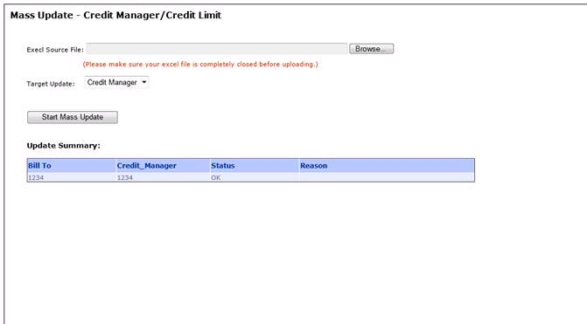

Figure 7.2 Mass Upload Screenshot

## Audit Trail

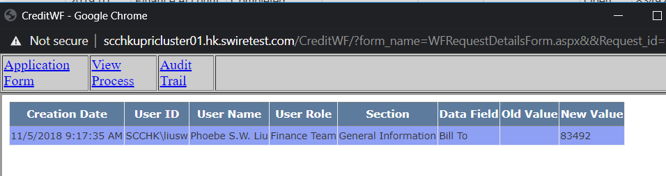

Figure 7.3 Audit Trail Screenshot

## Approval Flow

Existing approval flow of credit workflow has divided into 3 parts, GT, AWH and KA.

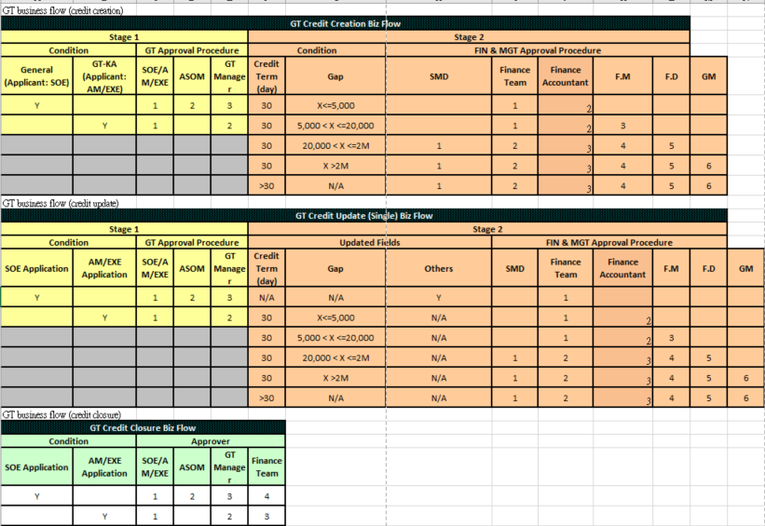

Figure 7.4.1 Approval Flow – GT

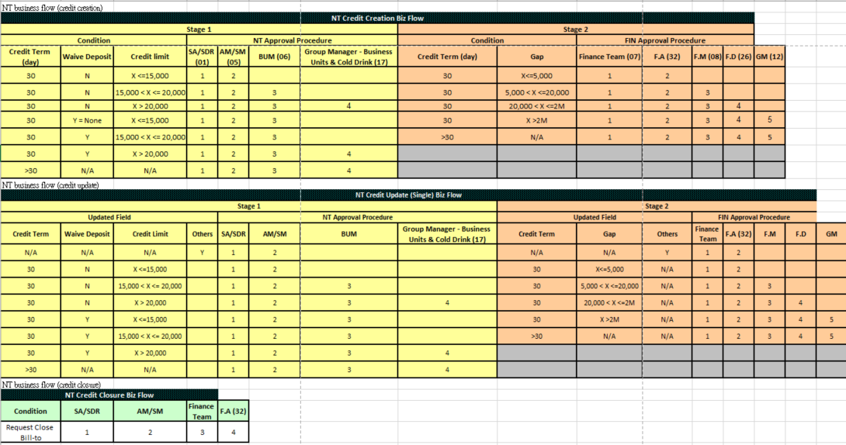

Figure 7.4.2 Approval Flow – AWH

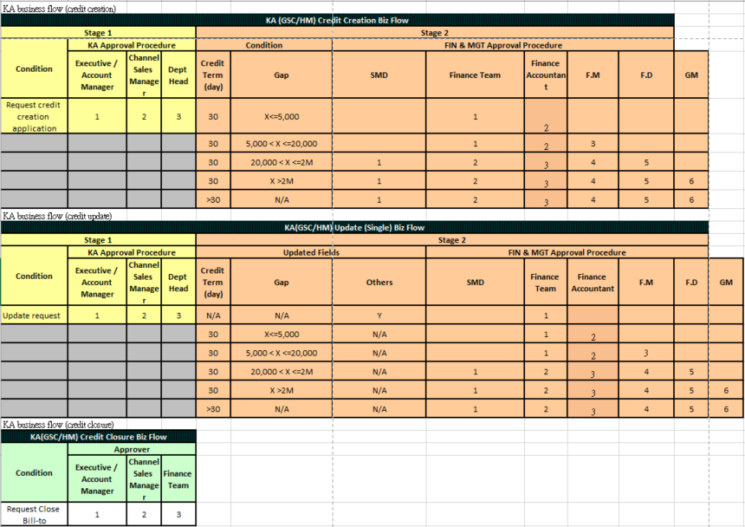

Figure 7.4.3 Approval Flow – KA

Methods and Procedures

# Summary of Improvements

The proposed credit workflow has four application actions: open, update, close and reopen and there will be approval flow to control. All applications will be recorded in the system and synchronize to SAP.

## Functional Improvements

### Open Credit Customer Profile



Figure 8.1.1 Open Credit Profile Process Flowchart

### Update Credit Customer Profile



Figure 8.1.2 Update Credit Profile Process Flowchart

### Update VBA



Figure 8.1.3 Update VBA Process Flowchart

### Close Credit Customer Profile



Figure 8.1.4 Close Credit Profile Process Flowchart

### Reopen Credit Customer Profile



Figure 8.1.5 Reopen Credit Profile Process Flowchart

# Assumptions and Constraints

### Assumption

The following assumptions are made to support the Credit Workflow.

1. Assume credit customer is created a unique BP profile in Credit workflow and sync to SAP BP master
2. Assume one credit customer can have many outlet BP but there is no upper parent.
3. Assume credit profile is maintained in Business Partner for bill-to and payer.

### Constraints

1. Security deposit is a reference field in CRWF. Actual posting is a manual process in SAP by Finance AR Team (including bank guarantee)

Detailed Requirements

# Functional Area System Functions

### Generic function

The system supports the following functions:

1. System requires initiator/application login to apply workflows.

Initiator is the current user login

Applicant default is the current user login, but it can be changed manually. And the department information is following the applicant’s user info.

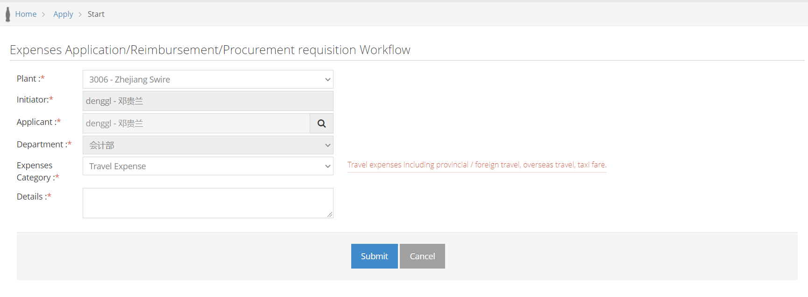

1. Initiator/Applicant can view their created forms

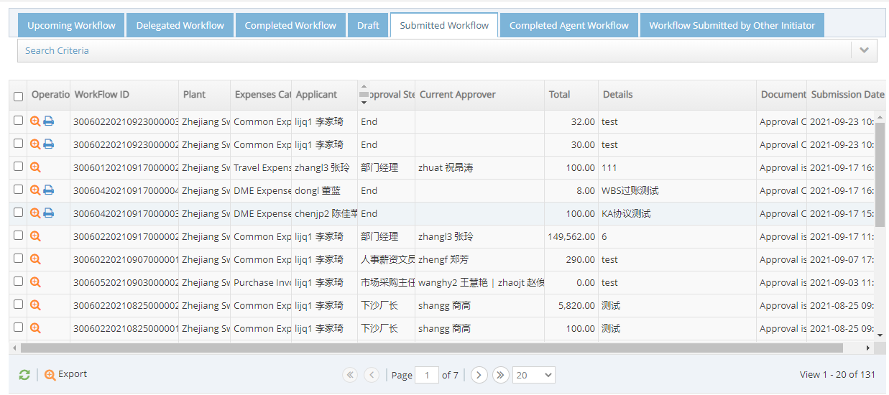

1. All approvers in the approver route can view their completed forms which they involved at different stages

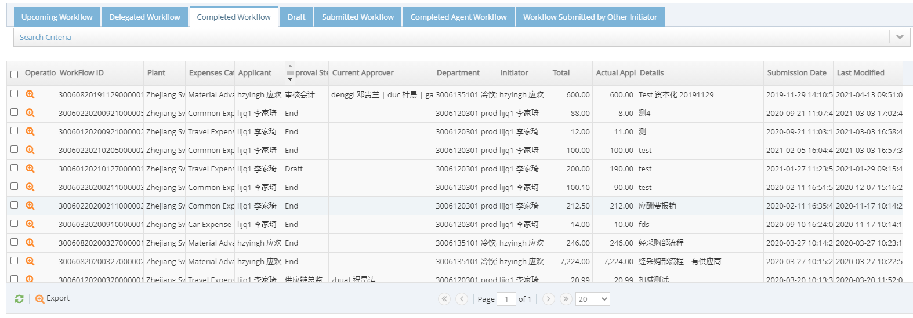

1. Workflow users can search their related forms

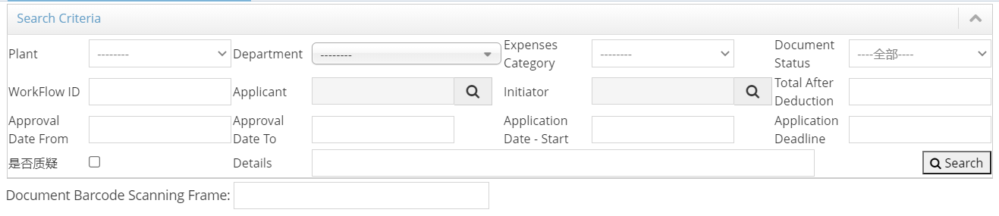

1. System supports delegation to workflow users to reassign action and information tasks to other workflow users for a period

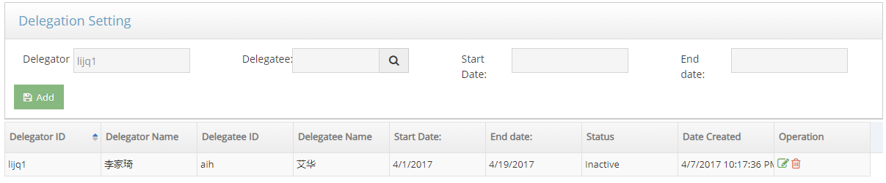

1. System supports audit trail function to trace back edit history with below columns:
   1. Creation Date – Changes created date in dd/mm/yyyy format
   2. User ID
   3. User Name
   4. User Role
   5. Section – Header title of the changed field section
   6. Data Field – Field name of changed field
   7. Old Value – Previous value of the data field
   8. New Value – To be update value of the data field



1. Changes indicator will be shown when approver is viewing the updated form. Changed field will be highlighted in yellow and the existing value will be shown when user mouse over to the field.

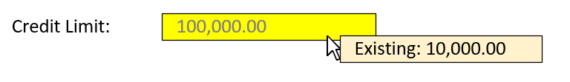

1. General application “Print” function is supported for printing the application form out after the application is submitted.

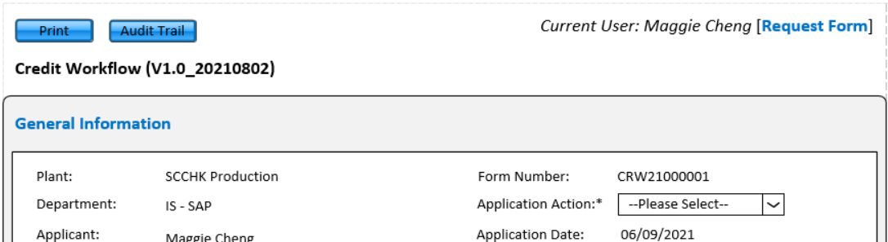

1. System shows user’s General Information on the top of the workflow form:
   1. Plant - Retrieved from the Application Start page
   2. Department - Retrieved from Applicant’s user info
   3. Applicant - Retrieved from Applicant’s user info
   4. Position - Retrieve from Applicant’s user info
   5. Form Number - Form Number is generated after the application is submitted
   6. Application Action - It depends on the application type’s category
   7. Application Date - in dd/mm/yyyy format
   8. Initiator – Initiator’s username



1. System supports multi-lines error message which highlighted in red and appears under General Information section

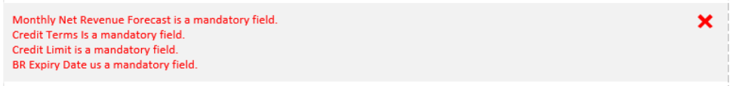

1. Workflow users can upload supporting documents with below columns: file storage directory
2. Item – For user to download or delete the uploaded item
3. File Name – Name of the file with file format
4. Uploader – Show the file uploader username
5. Upload Date – The file upload date and timestamp, in dd/mm/yyyy hh:mm:ss format



1. Workflow users can view the approval history with below columns:
2. Approval Role
3. Current Approver – Approver’s username
4. Approval Status
5. Date of Approval – Approval date with timestamp in dd/mm/yyyy hh:mm:ss format
6. Remark
7. Delegatee



1. Workflow users can input comments and submitted. Comments will be shown with:
2. Username – Input comment user’s username
3. Comment – Comment content
   * + 1. Max length will be shown under the comment textbox
4. Date – Comment input date with timestamp in dd/mm/yy hh:mm:ss format



1. Applicant/Initiator can save the application as draft before submitting to next stage

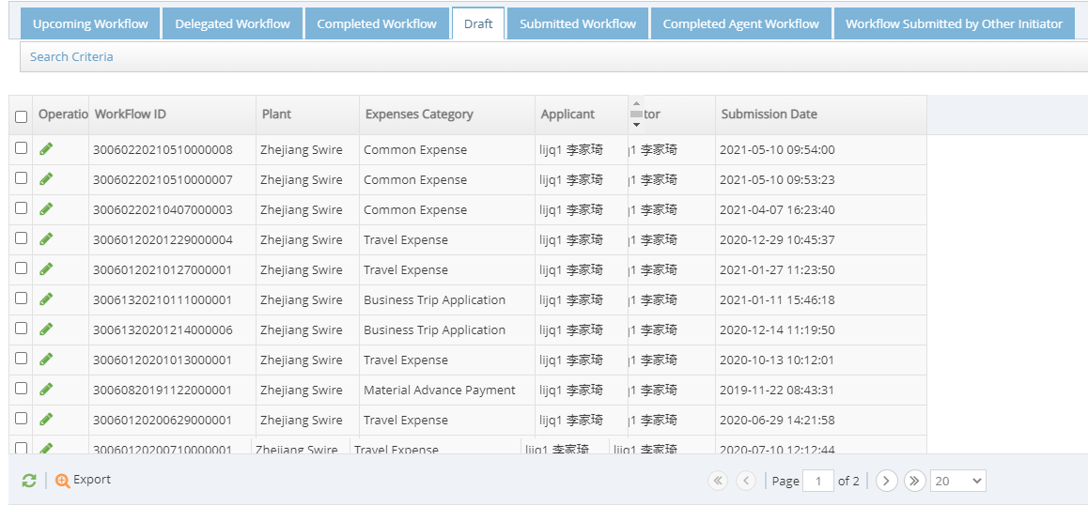

1. Approver can approve or reject the requested item
2. Skip the next approver if the next approver is the applicant/initiator
3. Flow the application form to assigned approver based on criteria
4. Applicant/Initiator can edit any rejected or returned application by approver and resubmit again
5. Applicant/Initiator can cancel or terminate any rejected application
6. System will send reminder/notification to any specified workflow users once the workflow item is assigned to them. Template as below:
7. Submit notification

|  |  |
| --- | --- |
| From | System mail account |
| To | Applicant email account |
| CC | Initiator email account |
| Subject | [WF Name] – New Request: [Form No] |
| Dear applicant,  Your new [Sub Application Name] application has been submitted (Form No: [Form No]). Click here to view the detail and status. | |

1. Delete draft notification

|  |  |
| --- | --- |
| From | System mail account |
| To | Initiator email account |
| CC | Applicant email account |
| Subject | [WF Name] – Delete Request: [Form No] |
| Dear initiator,  Your [Sub Application Name] application has been deleted (Form No: [Form No]). Click here to view the detail and status. | |

1. Approve notification

|  |  |
| --- | --- |
| From | System mail account |
| To | Next approvers’ email account |
| CC | Initiator email account, Applicant email account |
| Subject | [WF Name] – Approval request: [Form No] |
| Dear approver,  A [Sub Application Name] application (Form No: [Form No]) is pending for your approval. To read, please use this read-only link, or click here to approve the request. | |

1. Reject notification

|  |  |
| --- | --- |
| From | System mail account |
| To | Applicant email account |
| CC | Initiator email account, Next approvers’ email account |
| Subject | [WF Name] – Rejected request: [Form No] |
| Dear applicant,  The [Sub Application Name] application (Form No: [Form No]) is rejected by [Approver Name]. Click here to view the details and status. | |

1. Final approval notification

|  |  |
| --- | --- |
| From | System mail account |
| To | All approver in the approval route  Applicant email account |
| CC | Initiator email account |
| Subject | [WF Name] – Application Confirmed: [Form No] |
| Dear all,  The [Sub Application Name] application (Form No: [Form No]) is confirmed. Click here to view the details and status. | |

1. System will send reminder/notification to any specified workflow users after the form is outstanding for 3 working days
   1. Pending approval

|  |  |
| --- | --- |
| From | System mail account |
| To | Next approvers’ email account |
| CC | Initiator email account, Applicant email account |
| Subject | [WF Name] – Approval request: [Form No] |
| Dear approver,  A [Sub Application Name] application (Form No: [Form No]) is pending for your approval over 3 working days. To read, please use this read-only link, or click here to approve the request. | |

1. System supports error log for issue tracing in backend

### Open a new credit customer

1. Payer Information section
   1. User can choose Mass upload outlet list / Single BP input.
      1. For mass upload outlet list, user can follow the template to upload outlet list file. System will check whether the outlets exist in SAP (OTCMD010-005) or calling Outlet WF API (cmwf, details can refer to Appendix E Credit Workflow Field Mapping and Appendix F cmwf.postman_collection.json) for checking whether outlet(s) is/are approved in Outlet WF.

If Excel file uploaded successfully, message “There are `no. of upload outlet` outlets uploaded. Outlet no.: `all outlet(s) no.`” will be shown.

Error message “Invalid record contains. Please check and reupload.” will be shown if any record of the file is invalid.

* + 1. For Sigle BP input, user can input the Reference BP no. manually. System will check the input format (e.g. in specific BP No. range) and error message “Invalid BP Number. Please check.” will be shown if the BP no. is invalid.

|  |  |  |  |  |
| --- | --- | --- | --- | --- |
| **Grouping** | **Desc** | **From** | **To** | **Remarks** |
| Z001 | Customer (Ext) | 120 + current customer code | | Customer Code for Migration (for both outlet & Bill-to) e.g. 1200205250 |
| 1210000000 | 1214999999 | Payers from Credit Workflow |
| 1215000000 | 1219999999 | Payers (Manual application) |
| 1240000000 | 1289999999 | Outlets from Outlet Workflow |
| 1290000000 | 1299999999 | Outlets (Manual application) |

Figure 10.1.2 BP No. range table

* 1. System will take the first record from Excel file as main outlet to retrieve the BP information if user has chosen mass upload outlet list, or system will follow the input Reference BP no. to retrieve the BP information from SAP (OTCMD010-007). User can modify the Bill to information. Excel file template as below:

|  |
| --- |
| Outlet No |
| 123123141 |
| 232132142 |

* + 1. Exception handling from SAP

1. Bill-to No. Assignment
   1. Bill-to number will be auto assigned by the workflow system once the application approved
   2. Bill-to number range can refer to Figure 10.1.2 BP No. range table
2. AR Information section
   1. Fields appear when "Open" is selected in Application Action:
      1. Customer Status
      2. Monthly Forecast Net Revenue
      3. Score of Credit Term
      4. Score of Security Deposit
   2. "Monthly Net Revenue Forecast" becomes editable when "Change from COD" or "New Non-FSV Customer" is selected in "Customer Status"
   3. "Score of Credit Term" value changes based on the “Credit Term” selection (Refer to Appendix A: Credit Policy – Appendix C)
   4. “Score of Security Deposit” value changes based on the “Customer Type” selection. (Refer to Appendix A: Credit Policy – Appendix C)
      1. “Score of Security Deposit” will set as 1 when "Listed Company / Gov / Global KA of KO" is selected in "Customer Type"
      2. For others, the value depends on the Security Deposit / Preliminary Credit Limit Ratio, and

Preliminary Credit Limit = Monthly Net Revenue Forecast x Score of Credit Term

* 1. “Credit Limit” value changes by cases
     1. For reimbursement FSV, each vending machine will be requested $2000 security deposit as Credit Limit. System will set "Credit Limit" to 2000 when "FSV Customer" is selected in "Customer Status" (Refer to Appendix B: Credit Policy – Appendix E). If customer has more than one vending machine, user requires to manual input the Credit Limit as 2000 x no. of vending machine (Refer to Appendix D: RTRMD130-Business Partner Credit Limit Master Record Maintenance Blueprint)
     2. For the rest, value changes based on the values of "Monthly Net Revenue Forecast" and "Scored of Credit Term" and "Scored of Security Deposit” (Refer to Appendix A: Credit Policy – Appendix C)

Credit Limit = Preliminary Credit Limit x Score of Security Deposit

Preliminary Credit Limit = Monthly Net Revenue Forecast x Score of Credit Term

* 1. Some fields only visible for Finance user (Details can refer to Appendix C: Credit Workflow Fields Description)
     1. Risk Class

|  |  |  |
| --- | --- | --- |
| **Risk class** | **Name** | **Action** |
| A | Low credit risk | No action |
| B | Mid-low credit risk | Block sales order |
| C | Middle Credit Risk | Block sales order |
| D | Mid-high Credit Risk | Block sales order |
| E | No Credit Risk | No action |

* + 1. Check Rule

Default value is “Z4 - Check Credit limit and Overdue > 30 days”.

|  |  |  |  |
| --- | --- | --- | --- |
| **Check rule** | **Name** | **Check credit limit** | **Check overdue AR** |
| KA | Control at KA level, no credit check at self level | - | - |
| Z1 | No Credit Check | N | N |
| Z2 | Check Credit limit and Overdue > 0 day | Y | Y, AR > 0 day |
| Z3 | Check Credit limit and Overdue > 45 days | Y | Y, AR > 45 days |
| Z4 | Check Credit limit and Overdue > 30 days | Y | Y, AR > 30 days |
| Z5 | Check Credit limit and Overdue > 7 day | Y | Y, AR > 7 days |
| Z6 | Check Credit limit only | Y | N |
| ZX | Cash Customer - Check Overdue > 0 day only | N | Y, AR > 0 day |

* + 1. Virtual Bank Account
  1. “Statement Print Option” control
     1. For “Softcopy”, SAP will send electronic copy for softcopy customer
     2. For “Hardcopy”, SAP will print the summary invoice for pre-printed paper customer
     3. For “EDI Invoice”, SAP will generate EDI orders interface file to GSX and invoice can be viewed in SAP.
     4. For “EDI Invoice + EDI Summary”, SAP will generate EDI orders interface file to GSX and print out a human readable EDI summary
  2. Virtual Bank Account handling
     1. After Sales team raised “Create Credit Profile” request and got Sales department approval (Approver layer is based on the credit limit amount), Finance clerk can input the VBA field and system will verify the input whether match with the HSBC supplied range or not. Finance team will provide the full list of the HSBC supplied range for developers to upload to the system for checking. Once Finance clerk updated the VBA, the application will flow to Finance accountant (follows the approval matrix)

1. BR Information section
   1. User requires to fill in Business Registration Name, Number and Expiry Date.
2. Hidden fields handling
   1. After user created BP through Outlet Workflow, some field values are defaulted and will not be shown in Credit Workflow (Details can refer to Appendix C: Credit Workflow Fields Description)

### Update an existing credit customer

1. Payer Information section
   1. User requires to input Bill-to number. System will perform validation checking: (OTCMD010-007)
      1. System will check the input format.

Error message “Invalid Bill-to number. Please check.” will be shown if input Bill-to no. is invalid.

* + 1. System will check whether the Payer is valid for "Update" or not.

If payer status is not “Open”, error message “Invalid payer. Please check.” will be shown.

If payer’s credit limit is expired, error message “Payer’s credit limit is expired. Please reopen the credit customer profile.”

* 1. System will retrieve related BP information from SAP with exception handling

1. AR Information section
   1. System will retrieve latest credit profile information from SAP (OTCMD010-007) and non-SAP data from local database (Details can refer to Appendix C: Credit Workflow Fields Description)
   2. System will hide the fields only available for “Open” credit profile:
      1. Customer Status
      2. Customer Type
      3. Monthly Forecast Net Revenue
      4. Score of Credit Term
   3. System will not apply calculation of below fields in “Update” state:
      1. Score of Credit Term
      2. Score of Security Deposit
   4. Some fields only visible for Finance user (Details can refer to Appendix C: Credit Workflow Fields Description)
      1. Risk Class
      2. Check Rule
      3. Virtual Bank Account
   5. Virtual bank account field handling
      1. VBA field only visible to Finance users. After Sales team raised “Update Credit Profile” request, the field can be updated by Finance clerk once the application got Sales department approval. After Finance clerk input the VBA field, system will verify the input whether match with the HSBC supplied range or not. Finance team will provide the full list of the HSBC supplied range for developers to upload to the system for checking. Once Finance clerk updated the VBA, the application will be based on the credit limit to continuous the approval flow (Details can refer to 10.2 Approval Flow)
2. BR Information section
   1. System will retrieve latest business registration information from SAP (OTCMD010-007)

### Update VBA

1. Payer Information section
   1. User requires to input Bill-to number. System will perform validation checking: (OTCMD010-007)
      1. System will check the input format.

Error message “Invalid Bill-to number. Please check.” will be shown if input Bill-to no. is invalid.

* + 1. System will check whether the Payer is valid for "Update" or not.

If payer status is not “Open”, error message “Invalid payer. Please check.” will be shown.

If payer’s credit limit is expired, error message “Payer’s credit limit is expired. Please reopen the credit customer profile.”

* 1. System will retrieve related BP information from SAP with exception handling (OTCMD010-007)
  2. User is not able to edit any fields of Payer Information

1. AR Information section
   1. System will retrieve latest credit profile information from SAP (OTCMD010-007) and non-SAP data from local database (Details can refer to Appendix C: Credit Workflow Fields Description)
   2. System will hide the fields only available for “Open” credit profile:
      1. Customer Status
      2. Customer Type
      3. Monthly Forecast Net Revenue
      4. Score of Credit Term
   3. System will not apply calculation of below fields in “Update” state:
      1. Score of Credit Term
      2. Score of Security Deposit
   4. Some fields only visible for Finance user (Details can refer to Appendix C: Credit Workflow Fields Description)
      1. Risk Class
      2. Check Rule
      3. Virtual Bank Account
   5. User is not able to edit any fields of AR Information except “Virtual Bank Account”
   6. Virtual Bank Account handling
      1. Only Finance Clerk can raise “Update VBA” request to update the VBA field value. After Finance clerk submitted the “Update VBA” request, system will verify the input whether match with the HSBC supplied range or not. Finance team will provide the full list of the HSBC supplied range for developers to upload to the system for checking. Once Finance clerk updated the VBA, the application will be based on the credit limit to continuous the approval flow (Details can refer to 10.2 Approval Flow)
2. BR Information section
   1. System will retrieve latest business registration information from SAP (OTCMD010-007)

### Close an existing credit customer

1. Payer Information section
   1. Close Reason dropdown list will be shown. User requires to choose the close reason.
   2. User requires to input Bill-to number. System will perform validation checking: (OTCMD010-007)
      1. System will check the input format. Error message will be shown if input Bill-to no. is invalid.
      2. System will check whether the Payer is valid for "Close" or not, including payer exists, payer's credit limit is not expired and bill-to has less than or equal to 1 outlet relation
   3. System will retrieve related BP information from SAP with exception handling (OTCMD010-007)
2. AR Information section
   1. System will retrieve latest credit profile information from SAP (OTCMD010-007) and non-SAP data from local database (Details can refer to Appendix C: Credit Workflow Fields Description) with exception handling
   2. System will hide the fields only available for “Open” credit profile:
      1. Customer Status
      2. Monthly Forecast Net Revenue
      3. Score of Credit Term
      4. Score of Security Deposit
   3. System will not apply calculation of below fields in “Close” state:
      1. Score of Credit Term
      2. Score of Security Deposit
   4. All fields are non-editable in “Close” state except Comment section
3. BR Information section
   1. System will retrieve latest business registration information from SAP (OTCMD010-007)
4. Closure validation (OTCMD010-010)
   1. Before closing the bill-to, system will check whether the Bill-to has less than or equal to 1 outlet relation. After the application is approved, system will set “Credit Limit” and “Security Deposit” as 0, update “Check Rule” to “ZX” and set “Credit Expiry Date” as current date.

### Reopen a closed credit customer

1. Payer Information section
   1. User can choose Mass upload outlet list / Single BP input.
      1. For mass upload outlet list, user can follow the template to upload outlet list file. System will check whether the outlets exist in SAP (OTCMD010-005) or approved in Outlet WF. Error message will be shown if any record of the file is invalid.

If Excel file uploaded successfully, message “There are `no. of upload outlet` outlets uploaded. Outlet no.: `all outlet(s) no.`” will be shown.

Error message “Invalid record contains. Please check and reupload.” will be shown if any record of the file is invalid.

* + 1. For Sigle BP input, user can input the Reference BP no. manually. System will check the input format (e.g. in specific BP No. range) and error message “Invalid BP Number. Please check.” will be shown if the BP no. is invalid.
  1. System will take the first record from Excel file as main outlet to retrieve the BP information if user has chosen mass upload outlet list, or system will follow the input Reference BP no. to retrieve the BP information from SAP. User can modify the Bill to information.

1. AR Information section
   1. System will retrieve latest credit profile information from SAP or local database
   2. Fields appear when "Reopen" is selected in Application Action:
      1. Customer Status
      2. Monthly Net Revenue Forecast
      3. Score of Credit Term
      4. Score of Security Deposit
   3. "Monthly Net Revenue Forecast" becomes editable when "Change from COD" or "New Non-FSV Customer" is selected in "Customer Status"
   4. "Score of Credit Term" value changes based on the “Credit Term” selection (Refer to Appendix A: Credit Policy – Appendix C)
   5. “Score of Security Deposit” value changes based on the “Customer Type” selection. (Refer to Appendix A: Credit Policy – Appendix C)
      1. “Score of Security Deposit” will set as 1 when "Listed Company / Gov / Global KA of KO" is selected in "Customer Type"
      2. For others, the value depends on the Security Deposit / Preliminary Credit Limit Ratio, and

Preliminary Credit Limit = Monthly Net Revenue Forecast x Score of Credit Term

* 1. “Credit Limit” value changes by cases
     1. For reimbursement FSV, each vending machine will be requested $2000 security deposit as Credit Limit. System will set "Credit Limit" to 2000 when "FSV Customer" is selected in "Customer Status" (Refer to Appendix B: Credit Policy – Appendix E) If customer has more than one vending machine, user requires to manual input the Credit Limit as 2000 x no. of vending machine (Refer to Appendix D: RTRMD130-Business Partner Credit Limit Master Record Maintenance Blueprint)
     2. For the rest, value changes based on the values of "Monthly Net Revenue Forecast" and "Scored of Credit Term" and "Scored of Security Deposit” (Refer to Appendix A: Credit Policy – Appendix C)

Credit Limit = Preliminary Credit Limit x Score of Security Deposit

Preliminary Credit Limit = Monthly Net Revenue Forecast x Score of Credit Term

* 1. Some fields only visible for Finance user (Details can refer to Appendix C: Credit Workflow Fields Description)
     1. Risk Class
     2. Check Rule
     3. Virtual Bank Account
  2. “Statement Print Option” control
     1. For “Softcopy”, SAP will send electronic copy for softcopy customer
     2. For “Hardcopy”, SAP will print the summary invoice for pre-printed paper customer
     3. For “EDI Invoice”, SAP will generate EDI orders interface file to GSX and invoice can be viewed in SAP.
     4. For “EDI Invoice + EDI Summary”, SAP will generate EDI orders interface file to GSX and print out a human readable EDI summary
  3. Virtual Bank Account handling
     1. After Sales team raised “Reopen Credit Profile” request and got Sales department approval (Approver layer is based on the credit limit amount), Finance clerk can input the VBA field and system will verify the input whether match with the HSBC supplied range or not. Once Finance clerk updated the VBA, the application will be based on the credit limit to continuous the approval flow (Details can refer to 10.2 Approval Flow)

1. BR Information section
   1. System will retrieve latest business registration information from SAP (OTCMD010-007)
2. Credit management validation
   1. System will check “Credit Limit” is not 0 or null, “Check Rule” is not “ZX” and “Credit Expiry Date” is not empty or earlier than application approval date

### Update partner function linkage in SAP

1. Create / Reopen credit customer

When the Create / Reopen credit customer request got final approval, system will check whether outlet exists in SAP. If the outlet exists in SAP, system will link the partner function directly (OTCMD010-002). Otherwise, system will get the outlet effective date from Outlet Workflow and set up workflow background job to get outlet effective date from Outlet Workflow through API (cmwf, details can refer to Appendix E Credit Workflow Field Mapping and Appendix F cmwf.postman_collection.json) and update partner function linkage in SAP once the effective date is reached (OTCMD010-002).

1. Update credit customer

Partner function linkage cannot be updated through CRWF. For details, please refer to Outlet Workflow.

1. Close credit customer

Remove partner function linkage is required before user submit the Close credit customer request. For details, please refer to Outlet Workflow

## Approval Flow

1. General

Both FSV reimbursement customer and non-FSV customer followed the same approval flow.

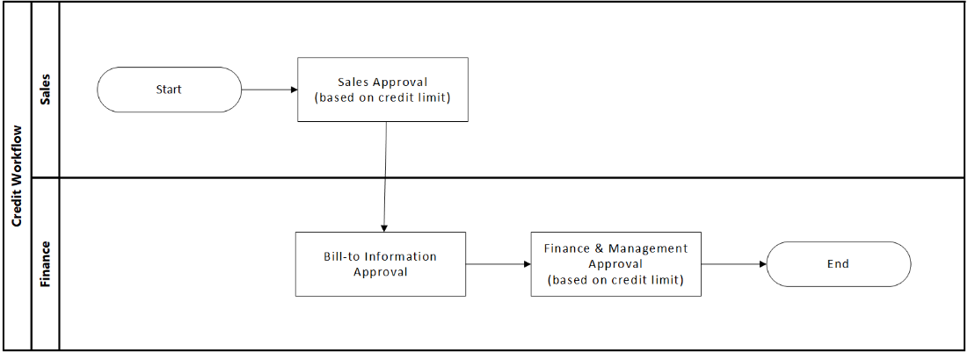

|  |  |  |  |  |  |  |  |  |  |
| --- | --- | --- | --- | --- | --- | --- | --- | --- | --- |
|  |  | **Approval in Sales Dept** | | | **Approval in Finance & Management** | | | | |
| **Application Type** | **Approval Threshold** | **SM** | **DM** | **SD** | **Clerk** | **Acct** | **AM/FM** | **FD** | **GM** |
| Open / Update / Reopen | <= 0 | Y |  |  | Y |  |  |  |  |
| <= 8,000 | Y |  |  | Y | Y |  |  |  |
| <= 50,000 | Y | Y |  | Y | Y | Y |  |  |
| <= 2,000,000 | Y | Y | Y | Y | Y | Y | Y |  |
| > 2,000,000 | Y | Y | Y | Y | Y | Y | Y | Y |
| Close | >=0 | Y | Y |  | Y | Y |  |  |  |

The approval flow is based on the amount of Approval Threshold (Approval Threshold = Credit Limit amount - Security Deposit). For larger threshold, might need more layers’ approval. (Refer to Appendix B: Credit Policy – Appendix E)

The logic for determine the approval threshold:

* 1. If “Credit Limit” / “Payment Terms” / “Security Deposit” / “Virtual Bank Account” is updated in the for open / update, the Approval Threshold = Credit Limit amount - Security Deposit
  2. If “Credit Limit” / “Payment Terms” / “Security Deposit” / “Virtual Bank Account” is not updated in the for open / update, the Approval Threshold = -1
  3. If it is a close application, the Approval Threshold = credit limit

1. Approval Amount
   1. For FSV, the amount of security deposit should be HKD2,000 per vending machine and Credit Limit should be the same (Refer to Appendix B: Credit Policy – Appendix E)
   2. For the rest,
      1. Approval Amount = Credit Limit - Security Deposit
      2. Different roles can approve different amount (Refer to Appendix B: Credit Policy – Appendix E)
2. Approval Status Update
   1. Approval Stage and status should be record in local database once the Approval flow is started
3. Final Approval
   1. Synchronize the BP master data to SAP
      1. Delta Changes only
   2. Synchronize the credit profile to SAP
      1. Delta Changes only
   3. Synchronize all data to local database
   4. Update partner function linkage in SAP if necessary (Details can refer to 11.1.7 Update partner function linkage in SAP)

## Screen Navigation

### Payer Information

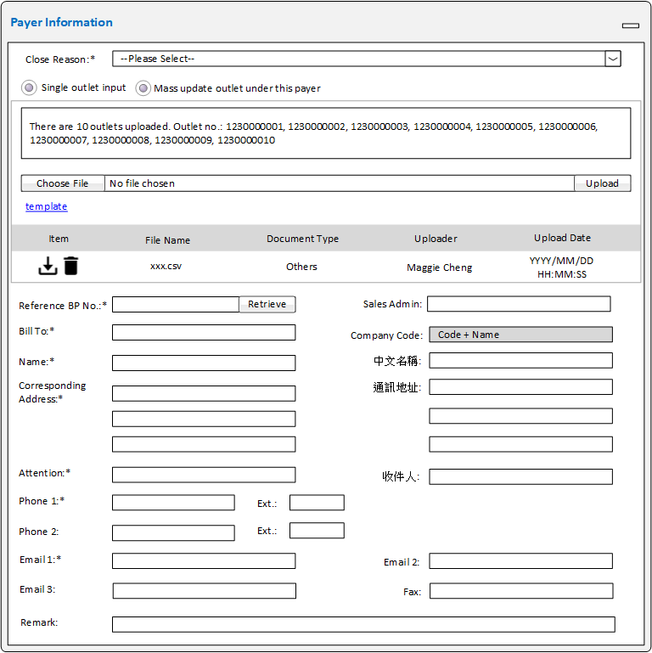

### AR Information



### BR Information



## Integration Interface

|  |  |  |  |
| --- | --- | --- | --- |
| **JIRA No.** | **RICEFW ID** | **RFC** | **Description** |
| **SCPHK-318** | OTCMD010-002 |  | Create / Update Business Partner (Payer) Information  Update Payer and outlet linkage |
| **SCPHK-299** | RTRMD130-001 |  | Create / Update Payer's credit profile |
| **SCPHK-504** | OTCMD010-005 |  | Sync Code and Value from SAP (OTC) |
| **SCPHK-508** | OTCMD010-010 |  | Payer closure RFC  - Check if any linkage with existing outlet (status = open)" |
| **SCPHK-506** | OTCMD010-007 |  | Retrieve Payer Information |
| **SCPHK-551** | RTRMD130-007 |  | Interface - outbound BP Bank Key\Bank Account\Virtual Bank Account to CR workflow for BP creation |
| **SCPHK-688** | RTRMD130-008 |  | Retrieve Credit Master Information |

## Data Migration

## Access Right Definition

| Item | | | Module | Module Description | | |  |  |  | |  |  |  |  |  |
| --- | --- | --- | --- | --- | --- | --- | --- | --- | --- | --- | --- | --- | --- | --- | --- |
|  | | |  |  | | |  |  |  | |  |  |  |  |  |
|  | | |  |  | | |  |  |  | |  |  |  |  |  |
| Legend: | | | | | | | | | | | | | | | |
|  | W | Update Access | | | R | Read Only Access | | | | N | No Access | | | | |

Open Issues

| No. | Description | Who | When |
| --- | --- | --- | --- |
| 1. |  |  |  |
| 2. |  |  |  |
| 3. |  |  |  |

Acronyms and Abbreviations

| Abbreviation | Description |
| --- | --- |
| CRWF | Credit Workflow |
| BP | Business Partner |
| BR | Business Registration |
| SCCHK | Swire Coca-Cola Hong Kong |
| VBA | Virtual Bank Account |

Appendixes

## Appendix A: Credit Policy – Appendix C



## Appendix B: Credit Policy – Appendix E



## Appendix C: Credit Workflow Fields Description



## Appendix D: RTRMD130-Business Partner Credit Limit Master Record Maintenance Blueprint



## Appendix E: Credit Workflow Field Mapping

## Appendix F: cmwf.postman_collection.json